Exercise #4
- List the first and last name of all employees whose salary is less than or equal to $90000 and are not Programmers, Senior programmers or MultiMedia programmers.
SELECT DISTINCT f_name, l_name
FROM employee
WHERE salary <= 9000
AND title NOT IN ('Programmer', 'Senior Programmer', 'Multimedia Programmer');

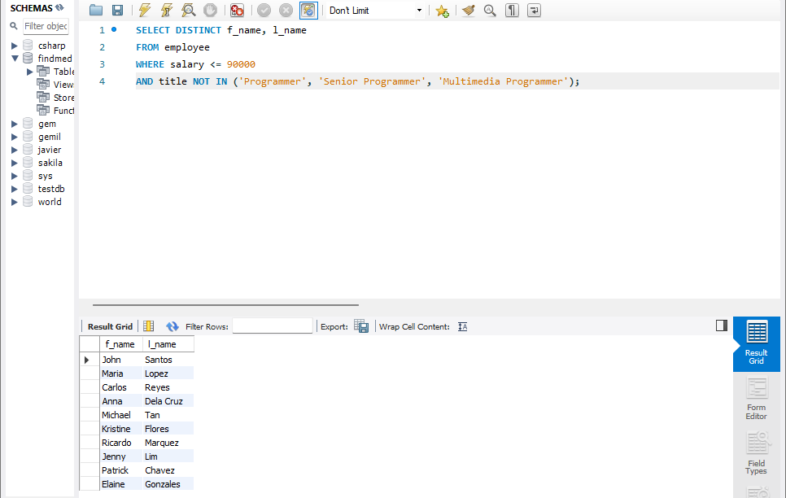

- What is displayed by the following statement?
Select l_name, f_name from employee_data where title NOT LIKE ‘%marketing%’ AND age < 30;
- List all ids and names of all employees between 32 and 40 years of age
SELECT id, CONCAT(f_name, ' ', l_name) AS full_name FROM employee_data WHERE age BETWEEN 32 AND 40;
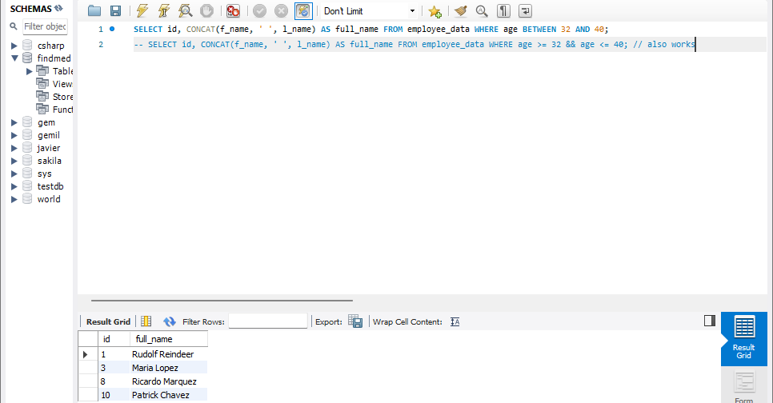

- Select names of all employees who are 32 of age and are not programmers.
SELECT f_name, l_name FROM employee WHERE age = 32 AND title NOT IN ('Programmer', 'Senior Programmer', 'Multimedia Programmer');
